**IMPLEMENTATION OF MODERN ONLINE HOTEL BOOKING SYSTEM**

A Capstone Project Proposal Presented to the Faculty of the

College of Computer Studies Department

**BENEDICTO COLLEGE - MANDAUE CAMPUS**

A.S. Fortuna St., Mandaue City, Cebu

In Partial Fulfillment of the Requirement for the Degree of

**Bachelor of Science in Information Technology**

Niel Ivan M. Eroy  
Jurace L. Lomutos  
Andrew Czar S. Mata  
Sean Ivan Ostria  
Rey Nino D. Perez

May 2025

**APPROVAL SHEET**

The Capstone Project Proposal entitled “**IMPLEMENTATION OF MODERN ONLINE HOTEL BOOKING SYSTEM**” prepared and presented by Eroy, Niel Ivan M. Eroy, Jurace L. Lomutos, Andrew Czar S. Lomutos, Mata, Sean Ivan Ostria, Rey Nino D. Perez, in partial fulfillment of the requirements for subject IT ELECTIVE II will be examined and presented for acceptance and approval for **Oral Examination.**

**CAPSTONE PROJECT ADVISORY COMMITTEE**

**GENE PAUL R. CUEVA, MBA, MSIT**

Chairman

**LENY B. YAMILO**, LPT **JOSE MARCELITO D. BRIGOLI**

Adviser Member

Approved by the Committee on Project Presentation with a grade of ____________

**PROF. GENE PAUL R. CUEVA, MBA, MSIT**

Chairman

**PROF. LENY B. YAMILO,**  **PROF. JOSE MARCELITO D. BRIGOLI**

Adviser Member

**ACCEPTED AND APPROVED** in partial fulfillment of the degree **BACHELOR OF SCIENCE IN INFORMATION TECHNOLOGY**

Date of Project Presentation:

**PROF. GENE PAUL R. CUEVA** Dean, CCS

**ABSTRACT**

|  |  |
| --- | --- |
| TITLE | IMPLEMENTATION OF MODERN ONLINE HOTEL BOOKING SYSTEM |
| RESEARCHERS | EROY, NIEL IVAN M.  LOMUTOS, JURACE L.  MATA, ANDREW CZAR S.  OSTRIA, SEAN IVAN  PEREZ, REY NINO D. |
| DEGREE | BACHELOR OF SCIENCE IN INFORMATION TECHNOLOGY |
| ADVISER | PROF. LENY B. YAMILO |
| INSTITUTION AND ADDRESS | BENEDICTO COLLEGE, A.S. FORTUNA ST., BAKILID, MANDAUE CITY |
| NUMBER OF PAGES |  |

This project focuses on developing an Online Hotel Booking System to streamline the booking process, enhance operational efficiency, and improve guest satisfaction. The hospitality industry's growth has driven the need for efficient, user-friendly online booking systems. By addressing issues like inaccuracies, delays, and lack of real-time access, the system aims to overcome challenges in traditional booking methods.

Utilizing advanced technology, the system offers features such as real-time availability tracking, instant confirmations, and a custom interface for a seamless experience. The project includes analyzing existing systems, studying user preferences, and integrating data-driven design to build a reliable platform. Collaborating with hotels will ensure smooth implementation, reducing booking errors and improving staff efficiency, ultimately enhancing competitiveness in the digital market.

***Keywords***: *Online Hotel Booking System, Real-time Availability Tracking, Guest Satisfaction, and Operational Efficiency*

**Chapter 1**

**THE PROBLEM AND ITS SCOPE**

**Rationale**

Technology serves as the cornerstone of modern innovation, facilitating the development of tools and systems that enhance daily life and operational efficiency. In the hospitality industry, the emergence of automation, digital platforms, and real-time data access has transformed traditional practices, particularly in hotel reservation systems. These booking platforms now serve as the operational backbone of hotels, allowing for seamless reservation management, guest feedback analysis, and improved customer service.

With evolving guest expectations and the increasing complexity of hospitality operations, booking systems have undergone significant enhancements. Modern platforms integrate real-time functionalities, enabling stakeholders to monitor occupancy levels, tailor services based on guest preferences, and increase operational transparency. They also offer user-friendly features such as intuitive interfaces, availability checks, and personalized stay configurations, providing convenience for both users and administrators.

Manual reservation systems, in contrast, often suffer from delays, inaccuracies, and a lack of transparency. Issues such as double bookings, data entry errors, and slow response times hinder service delivery and guest satisfaction. Therefore, the shift from traditional phone or email-based reservations to centralized online booking systems represents a crucial innovation. These digital systems feature dynamic pricing, real-time communication, and customer review integrations to streamline operations and elevate service quality.

Furthermore, the integration of automation reduces the administrative burden on hotel staff, allowing them to focus on delivering superior guest services. Standardized digital processes foster consistency and accuracy, enhancing customer trust and system reliability. Features like live availability tracking, automated rate adjustments, and instant confirmations redefine how hotels manage guest interactions and operational workflows.

Despite their benefits, online booking systems present certain challenges. Technical issues such as system downtime or internet connectivity problems can disrupt operations. Additionally, transitioning from manual to digital systems necessitates training and adaptation among users unfamiliar with technological tools.

This study seeks to address these inefficiencies by developing a streamlined, data-driven online hotel booking system designed to reduce human error, enhance real-time visibility, and improve booking accuracy.

The overarching objective is to design a reliable, efficient, and accessible system that enhances user experience, optimizes resource management, and modernizes hotel operations in a competitive digital landscape.

**Theoretical Background**

The landscape of hotel management and guest services has evolved significantly with the development and broad adoption of online booking systems. These systems leverage technology to enhance the efficiency, transparency, and convenience of the reservation process. The theoretical foundations of online booking systems are rooted in recent studies, technology-driven hospitality models, and service-oriented concepts.

Online hotel booking systems streamline the entire reservation experience,

offering real-time availability, instant confirmations, and personalized guest preferences, making them indispensable tools in modern hospitality management. By integrating advanced features, these systems not only improve operational efficiency but also enhance guest satisfaction through seamless communication, dynamic pricing, and customizable stay options.

**Online Experiences and Flow Theory (Bilgihan et al., 2013)** present a comprehensive examination of online customer experiences in the context of e-commerce, with particular attention to online hotel bookings. Utilizing the principles of flow theory, their research highlights how advancements in web technologies, such as HTML5, Ajax, and social media, have significantly enhanced customer engagement and satisfaction. The study emphasizes the importance of achieving a state of deep involvement, focus, and enjoyment during online interactions, which fosters outcomes like improved customer loyalty, a stronger brand image, and positive word-of-mouth marketing. The researchers advocate for emotional engagement, interactivity, and active participation as pivotal elements of successful e-commerce strategies, offering critical insights into optimizing online experiences for the hospitality industry.

**Theory of Lodging (Roberts et al., 2019)** propose an expanded theory of lodging, which examines guest behavior across various areas of a hotel environment. Initially centered on private spaces like guest rooms, the theory extends to include public and shared areas such as lobbies, restaurants, gyms, and spas. This research highlights the distinctions in human behavior between the familiar home environment and the structured, protective boundaries of a hotel setting. By analyzing these behavioral patterns, the theory provides a deeper understanding of the holistic lodging experience, enabling the hospitality industry to better cater to guest preferences and optimize their overall experience within different hotel facilities.

**Optimal Hotel Management Theory (Manachynska et al., 2020)** introduce the Optimal Hotel Management Theory, which addresses emerging trends in the hospitality industry through advanced management strategies. The theory presents a model for optimizing hotel service sales by using linear programming to balance the profitability of various room types within the overall hotel revenue structure. Emphasizing equilibrium pricing, the authors propose the "cobweb model" to account for supply and demand dynamics with time lags, enabling hotels to forecast prices and shape strategic pricing policies effectively. They also advocate for a rational assortment policy that allocates room types based on demand forecasts derived from the Markov chain method. Simulation modeling is suggested as a vital tool for enhancing decision-making, improving operational profitability, and refining strategic management practices. By integrating conventional analysis with innovative approaches such as multidimensional analysis, innovation performance evaluation, and stochastic modeling, the theory offers a comprehensive framework for maximizing profitability and fostering growth in the hotel industry.

**ONLINE HOTEL BOOKING SYSTEM**

**Online Experiences and Flow Theory (Bilgihan et al., 2013)**

**Theory of Lodging (Roberts et al., 2019)**

**Optimal Hotel Management Theory (Manachynska et al., 20220)**

**IMPLEMENTATION OF MODERN ONLINE HOTEL BOOKING SYSTEM**

**Figure 1**

**Theoretical Framework**

**Statement of the Problem**

In an era where technology plays a crucial role in the efficient management of hospitality services, many institutions continue to rely on outdated manual reservation processes. These methods, often based on basic practices like spreadsheets and verbal communications, lead to a variety of issues, including errors in room availability, delayed reservation confirmations, and limited flexibility to meet individual needs. The lack of a centralized system also impedes the effective tracking and management of reservations, which in turn adversely affects user experiences when accessing necessary resources. The requirement for all bookings to be manually processed further exacerbates inefficiencies and delays.

**General Problem of the Study**

Manual booking systems are prone to errors, miscommunication, and delays. Overbookings, lost reservations, and scheduling conflicts frequently occur, causing inefficiencies in managing availability. Without automation, tracking reservations and ensuring accurate records becomes difficult, leading to operational disruptions.

**Specific Problems of the Study**

1. Reservation and Bookings. Manual reservation system is prone to errors in room availability calculations, leading to overbookings and guest dissatisfaction. The system must incorporate automated checks and real-time updates to prevent these issues and ensure accurate bookings.
2. System Downtime and Technical Glitches. Interruptions in the booking process due to system failures can impact hotel operations. To enhance reliability, the system should include backup servers, regular maintenance protocols, and robust error-handling mechanisms.
3. Communication and Transparency. Efficient communication between guests and hotel staff are essential for a seamless booking experience. Features such as instant notifications, live availability tracking, and a user-friendly interface should be implemented to improve transparency and user satisfaction.

**General Objective of the Study**

This study aims to develop a reliable and user-friendly online hotel booking system that improves accessibility, efficiency, and usability for its intended users.

**Specific Objectives of the Study**

1. Eliminate reservation errors and overbookings. To implement an automated system with real-time updates and availability tracking, ensuring accurate and efficient bookings.
2. System maintenance. To integrate backup servers, regular maintenance protocols, and robust error-handling mechanisms for system reliability.
3. Enhance communication and transparency. To provide instant notifications, live availability tracking, and a user-friendly interface for both guests and hotel

**Scope**

This capstone project focuses on the development and implementation of an online hotel booking system designed to improve the efficiency, accuracy, and user-friendly experience of the reservation process. The system will automate various booking tasks by enabling users to view real-time room availability, make reservations, and receive instant confirmations. The system is designed to address common issues found in manual booking processes, such as overbookings, double entries, and delayed responses, through dynamic scheduling and automated notifications.

Administrative users will have complete control over reservation management, including the option to update, modify, or remove room schedules to meet guest requests, special events, or internal operational changes. The system will have a simple interface for both front-end users and administrators, facilitating communication and decreasing human error. While the platform's primary function is to facilitate bookings, it is also designed for scalability and future integration capabilities, such as prospective additions to reporting, analytics, and user account management. Furthermore, the system will include a Data Privacy Notification and User Terms and Agreement to ensure that users understand how their personal data is collected, stored, and used in accordance with applicable data privacy rules.

**Limitations**

Despite its comprehensive booking functionalities, the system is limited to reservation management and does not handle or process any form of payment transactions. All financial matters, including payment confirmation and verification, are managed exclusively by the hotel’s accounting department. As a result, the platform does not support online payment gateways such as Visa, GCash, PayMaya, or PNB, nor does it allow for cash-on-arrival or other unlisted payment methods. This limitation emphasizes the system’s primary focus on booking facilitation rather than financial processing.

The system does not support waitlisting or automatic rescheduling features, limiting flexibility during high-demand periods. If a preferred room or time slot is unavailable, guests must manually choose an alternative. This limitation may impact users during peak seasons when availability is scarce. Additionally, while guests can book multiple rooms if needed, the system ensures fair room allocation by preventing overbooking through accurate real-time availability tracking. While administrators have full control over adjusting room availability and schedules, the system’s performance is dependent on manual updates by hotel staff. Delays in these updates may affect the accuracy of information displayed to users and potentially disrupt the booking process.

**Significance of the Study**

**For businesses.** The system offers a streamlined process for managing bookings, reducing the likelihood of errors, and improving operational efficiency. By automating key functions such as room availability tracking, dynamic pricing, and instant confirmations, businesses can better manage their resources and improve the overall customer experience. The system's analytics capabilities will also provide valuable insights into booking patterns, allowing businesses to make informed decisions and optimize their operations.

**For the customers.** The system provides a more convenient and transparent way to book services. It allows users to easily check availability, receive instant booking confirmations, and modify their bookings as needed. The system's real-time updates and user-friendly interface contribute to a seamless booking experience, enhancing customer satisfaction.

**For the technology sector.** This study demonstrates the importance of user-centered design and technological innovation in solving real-world problems. The system highlights how technology can replace outdated manual processes, minimizing errors and improving the efficiency of booking management. The study also showcases how digital platforms can meet the needs of various businesses and industries by offering adaptable and scalable solutions.

**The academic community may also benefit from this study.** As it contributes to the growing body of research on how technology-driven solutions can enhance service delivery in the hospitality and other industries. The insights gained from this project can help inform future studies on booking systems, user experience, and the adoption of technology in business operations.

**For future researchers**. It can serve as a foundation for future research on improving online booking systems through technological advancements.

**Chapter 2**

**REVIEW OF RELATED LITERATURE AND STUDIES**

**Related Literature**

**Understanding Online Hotel Booking Process (Park et al., 2018)** explored the complexities of the online hotel booking process by applying the choice-set model. Using observation and survey methods, the study identifies dynamic patterns in decision-making influenced by internal and external factors, such as customer preferences, marketing strategies, and available technology. The findings reveal that the booking process is a multi-staged journey shaped by various stimuli and information sources. These insights provide valuable implications for hospitality marketers aiming to enhance customer engagement, improve satisfaction, and drive loyalty through targeted digital strategies.

**Hotel Booking Website (Kushwha et al., 2024)** designed a hotel management system that focuses on operational efficiency and user convenience. The system simplifies room availability management and guest bookings by providing real-time updates and user-friendly features. It enables guests to register, book units, and access essential hotel information seamlessly. This approach not only improves administrative workflows for hotel staff but also enhances the customer experience by offering a streamlined platform tailored to modern hospitality demands.

**User Experience in Internet Booking (Hussein et al., 2010)** assessed the effectiveness of internet booking services through the lens of user experience (UX). The research highlights usability issues that impact users’ ability to complete tasks efficiently, such as poorly designed interfaces and unintuitive navigation. Despite these challenges, users persist with online bookings for competitive pricing and convenience. The study underscores the importance of aligning UX design with user needs to minimize errors and optimize satisfaction, suggesting that well-designed interfaces are pivotal to sustaining customer loyalty.

**Impact of Online Reservation Systems and Customer Reviews (Faliha et al., 2021)** examined how online reservation systems and customer reviews influence brand image, trust, and booking decisions. The study highlights the transformative role of digital marketing strategies in expanding global reach and building trust through authentic customer feedback. By leveraging reservation systems for distribution and customer reviews for promotion, hotels can attract a broader audience and enhance their reputation. The findings emphasize the critical need for adapting these strategies to evolving market conditions and consumer behaviors.

**The Evolution of Online Booking Systems (Goecke, 2020)** chronicles the progression of online booking systems from early airline computer reservation systems to sophisticated web-based platforms. The study discusses how the integration of internet technologies and global distribution systems (GDS) revolutionized traditional booking processes. By offering user-friendly, browser-based solutions, these systems empower customers with self-service capabilities, streamlining the booking experience and transforming the landscape of e-tourism.

**Related Studies**

**Time, Price, and Advanced Booking of Hotel Rooms (Schwartz, 2008)** investigates the challenges faced by revenue management systems due to evolving online consumer behaviors, particularly the increasing trend of deal-seeking. The study highlights how traditional systems struggle to accommodate the dynamic nature of advanced-booking patterns. By extending the consumer booking model, Schwartz explores how time-before-the-date-of-stay affects hotel pricing strategies and marketing effectiveness. The findings reveal that timing patterns critically influence revenue outcomes, stressing the need for empirical research to adapt these systems to modern consumer behaviors. This study serves as a foundational resource for understanding the role of timing in optimizing revenue management within the hospitality industry.

**User Interface Design of Online Travel Booking Applications (Ani, 2019)** focuses on the critical role of user interface design in ensuring the usability and success of online travel booking applications. The study employs a five-phase methodology that includes defining research problems, collecting relevant literature, designing research methods, evaluating existing systems, and proposing a new user interface model. The resulting design incorporates features such as a comprehensive main menu with options for flights, hotels, trains, and promotional add-ons, as well as content sliders and an intuitive booking form. The study emphasizes the importance of aligning application interfaces with user needs to enhance satisfaction and adoption, offering a practical framework for developers aiming to improve the user experience in online booking systems.

**Factors Affecting Customer Trust in Online Hotel Booking Websites (Baki, 2020)** examines the factors influencing customer trust in online hotel booking platforms (OHBPs) amidst the growing role of internet technologies in the tourism industry. Data from 456 users were analyzed using structural equation modeling, revealing that elements such as website reputation, perceived security, ease of use, and risk perception significantly affect trust levels. Moreover, the study establishes a positive relationship between trust and customer loyalty, highlighting that users who trust a platform are more likely to return and recommend it to others. The findings offer actionable insights for OHBP managers, suggesting that enhancing trust-building mechanisms can lead to higher customer retention and improved brand loyalty.

**Impact of Online Reviews on Hotel Booking Intention (El-Said, 2020)** delves into the influence of online reviews on consumer decisions to book hotels. By collecting data from a sample of 432 customers, the study investigates the moderating effects of brand image, price importance, and star rating categories on the impact of reviews. The results indicate that while positive reviews have a limited effect on booking intentions, negative reviews carry a strong impact, significantly deterring potential customers. Additionally, brand image and pricing play nuanced roles in how reviews are perceived. The study underscores the importance for hotel managers to proactively address negative reviews and leverage positive feedback to capitalize on promotional opportunities, thereby enhancing consumer confidence and boosting bookings.

**E-Service and Online Hotel Booking Intentions (El Nemar et al., 2022)** examine the role of electronic services in shaping consumer intentions to book hotels online. By applying an adjusted Technology Acceptance Model (TAM), the study explores dimensions such as perceived ease of use, trust, and risk, alongside e-service quality attributes like interactivity and transparency. The findings, drawn from 154 hotel guests in Lebanon, show that trust and ease of use are key determinants of e-booking intentions, while perceived risk acts as a barrier. The research also highlights the need for hotel managers to focus on improving service quality and managing risks to foster customer confidence. This study provides a comprehensive understanding of consumer behavior, offering strategies to optimize online booking systems for higher adoption rates.

**Chapter 3**

**TECHNICAL BACKGROUND**

**Development Software**

In the ever-evolving landscape of the hospitality industry, technology integration has become essential for enhancing operational efficiency and improving service quality. One crucial aspect that has undergone transformation is the traditional approach to hotel reservations and bookings. The project aims to revolutionize how customers reserve accommodations while addressing the growing needs of modern travelers and hotel establishments. In response to these challenges, the researchers conceptualized and designed an advanced system to streamline reservation processes and improve booking management. This study explores the necessity of an automated system and the benefits it offers to both hotel operators and guests. By undertaking this project, the researchers aim to contribute to ongoing discussions about leveraging technology to optimize hotel management and improve customer experiences. To ensure the seamless development and deployment of the proposed system, the project will utilize the following software technologies.

**Front End Development Tools**

**What is HTML?**

HTML (Hypertext Markup Language). A standard markup language used for creating web pages and applications. It provides the basic structure of a website by defining elements such as text, images, links, and multimedia content.

**Why use HTML?**

HTML is essential because it serves as the backbone of any web page, providing the fundamental structure that browsers interpret and display. It ensures that content is well-organized and accessible, which is crucial for both user experience and search engine optimization (SEO). HTML works seamlessly with CSS and JavaScript, allowing developers to create fully functional, visually appealing, and interactive websites. It is also a universally recognized standard, meaning that any web browser can interpret and render HTML content consistently. Additionally, HTML5 introduces new semantic elements, multimedia support, and improved accessibility features, making modern web development more efficient and user-friendly.

**What is CSS?**

CSS (Cascading Style Sheets). A stylesheet language used to control the appearance and layout of web pages. It allows developers to modify colors, fonts, spacing, and responsiveness.

**Why use CSS?**

CSS is essential because it separates the design and structure of a web page, making it easier to maintain and update. It provides a visually appealing and consistent layout across multiple pages, enhancing the overall user experience. By enabling responsive design, CSS ensures that web pages adapt seamlessly to different screen sizes and devices, improving accessibility. It also allows developers to apply animations, transitions, and advanced styling effects without relying on JavaScript, leading to faster performance. Furthermore, CSS frameworks like Bootstrap and Tailwind CSS help streamline development, providing pre-styled components and grid systems for efficient design.

**What is JavaScript?**

JavaScript. Programming language used to create interactive and dynamic elements on web pages. It allows developers to add animations, handle user inputs, and update content in real time.

**Why use JavaScript?**

JavaScript is crucial because it enhances web pages with interactivity, making them more engaging and user-friendly. It allows for real-time updates without requiring a page reload, which improves performance and responsiveness. JavaScript is also versatile, as it can be used for both front-end and back-end development with frameworks like Node.js. Additionally, it supports third-party libraries and frameworks such as React, Angular, and Vue.js, which simplify the development of complex applications. With JavaScript, developers can implement client-side validation, interactive UI elements, and seamless API integrations, improving the overall functionality of web applications.

**Front-end Framework & Libraries**

**What is Angular?**

Angular. TypeScript-based front-end framework developed by Google for building dynamic, single-page web applications (SPAs). It follows a component-based architecture for modular and scalable development.

**Why use Angular?**

Angular is beneficial because it simplifies the development of complex web applications with its built-in tools for state management, dependency injection, and two-way data binding. It enhances performance by efficiently updating only the necessary parts of a web page, reducing unnecessary reloading. The framework promotes modularity, allowing developers to create reusable components, which speeds up development and improves maintainability. Additionally, Angular's strong typing with TypeScript reduces runtime errors and enhances code quality. With extensive community support and regular updates from Google, Angular remains a reliable choice for scalable and enterprise-level applications.

**Programming Language Used**

**What is JavaScript?**

A versatile, high-level programming language primarily used for creating interactive and dynamic web applications. It enables developers to implement features such as animations, real-time data updates, form validations, and event handling on websites.

**Why use JavaScript?**

JavaScript is essential for enhancing user experience by making web pages more interactive, responsive, and engaging. It enables real-time updates, allowing web applications to function smoothly without requiring full-page reloads, which improves performance. JavaScript also plays a crucial role in front-end and back-end development, as it can be used with frameworks like React, Angular, and Vue.js for UI development and Node.js for server-side applications. Additionally, its compatibility with various APIs allows seamless integration of third-party services such as payment gateways, maps, and authentication systems. With a vast ecosystem of libraries and frameworks, JavaScript remains one of the most powerful and widely used programming languages for modern web development.

**Back-end Technology**

**What is Node.js?**

Node.js. Runtime environment that allows JavaScript to be executed outside the browser, enabling developers to build server-side applications. It is built on Chrome’s V8 JavaScript engine and provides an event-driven, non-blocking architecture for high-performance applications.

**Why use Node.js?**

Node.js is essential because it allows developers to use JavaScript for both front-end and back-end development, creating seamless full-stack applications. Its non-blocking, event-driven architecture makes it highly efficient for handling multiple simultaneous connections, which is ideal for real-time applications like chat apps and online gaming. Node.js offers a vast ecosystem of open-source libraries via npm (Node Package Manager), reducing development time and effort. It also provides high scalability, making it suitable for microservices and cloud-based applications. Additionally, its lightweight and fast execution speed ensure better performance, especially for API-driven applications and data-intensive services.

**Back- end Framework**

**What is Sequelize?**

Powerful Object-Relational Mapping (ORM) library for Node.js that simplifies database management by allowing developers to interact with databases using JavaScript instead of raw SQL queries. It supports various relational databases, including MySQL, PostgreSQL, SQLite, and MariaDB.

**Why use Sequelize?**

Sequelize makes database management more efficient by providing an intuitive and structured way to interact with relational databases using models instead of writing complex SQL queries. It simplifies data operations by offering built-in methods for querying, updating, and deleting records, improving code readability and maintainability. The ORM supports database migrations, associations, and transactions, making it easier to scale applications and handle complex relationships between tables. Additionally, Sequelize enhances security by preventing SQL injection attacks through parameterized queries. Its flexibility and extensive documentation make it a popular choice for full-stack developers working with Node.js applications.

**What is Express.js?**

A lightweight and flexible web application framework for Node.js that simplifies the development of server-side applications. It provides tools and middleware to handle HTTP requests, routing, and APIs efficiently.

**Why use Express.js?**

Express.js is widely used because it simplifies backend development by offering a minimal yet powerful framework for building web applications and RESTful APIs. It allows developers to handle routing, middleware, and HTTP requests easily, improving code organization and maintainability. The framework is highly scalable, making it suitable for small projects as well as large, enterprise-level applications. Its middleware system enables efficient handling of authentication, logging, error management, and data processing. Furthermore, Express.js has strong community support and integrates well with databases like MySQL and MongoDB, making it a preferred choice for full-stack web development.

**Front-end design**

**What is Angular?**

TypeScript-based front-end framework developed by Google for building dynamic, single-page web applications (SPAs). It follows a component-based architecture for modular and scalable development.

**Why use Angular?**

Angular is beneficial because it simplifies the development of complex web applications with its built-in tools for state management, dependency injection, and two-way data binding. It enhances performance by efficiently updating only the necessary parts of a web page, reducing unnecessary reloading. The framework promotes modularity, allowing developers to create reusable components, which speeds up development and improves maintainability. Additionally, Angular's strong typing with TypeScript reduces runtime errors and enhances code quality. With extensive community support and regular updates from Google, Angular remains a reliable choice for scalable and enterprise-level applications.

**Database Management System: What is MySQL?**

**What is MySQL?**

Widely used open-source relational database management system (RDBMS) that enables efficient storage, retrieval, and management of structured data. It is known for its reliability, scalability, and performance, making it a popular choice for web applications, enterprise software, and data-driven platforms.

**Why use MySQL?**

MySQL is a powerful and flexible database management system that ensures efficient data handling through structured query language (SQL). It supports large-scale applications with high-speed performance, making it ideal for businesses of all sizes. With its robust security features, MySQL protects sensitive data through user authentication, encryption, and access control mechanisms. It also integrates seamlessly with various programming languages and frameworks, including Node.js, PHP, and Python, allowing developers to build dynamic applications. Additionally, MySQL's extensive documentation and active community provide valuable resources and support for troubleshooting and optimization.

**Tool**

**What is MySQL Workbench?**

MySQL Workbench. Unified visual tool designed for database architects, developers, and administrators to manage MySQL databases efficiently. It provides an integrated environment for database design, development, administration, and performance tuning.

**Why use MySQL Workbench?**

MySQL Workbench is a powerful tool that simplifies database management with its user-friendly graphical interface, eliminating the need for complex command-line operations. It allows developers to visually design databases, create and edit schemas, and generate SQL queries effortlessly. The built-in administration tools enable users to manage database connections, optimize performance, and perform backups efficiently. Additionally, its query editor provides syntax highlighting, auto-completion, and execution history, making it easier to work with SQL queries. MySQL Workbench also supports database migration, enabling seamless transitions from other database systems to MySQL, making it a valuable tool for both beginners and experienced developers.

**Integrated Development Environment**

**What is Visual Studio Code?**

Visual Studio Code (VS Code). Lightweight yet powerful open-source code editor developed by Microsoft. It supports multiple programming languages, offers a customizable interface, and provides advanced development tools like debugging, version control, and extensions.

**Why use Visual Studio Code?**

VS Code is widely used because of its versatility, speed, and extensive support for various programming languages and frameworks. It offers built-in IntelliSense, which provides smart code completion, syntax highlighting, and error detection, enhancing productivity for developers. With its integrated terminal and Git support, managing projects and collaborating with teams becomes seamless. Additionally, VS Code's marketplace provides a vast collection of extensions, allowing developers to tailor their development environment to their specific needs. Its cross-platform compatibility ensures that developers can use it on Windows, macOS, and Linux, making it a top choice for modern software development.

**API Development**

**What is a REST API?**

A REST API (Representational State Transfer Application Programming Interface) is a web service that enables communication between client and server applications over HTTP. It follows RESTful principles, ensuring stateless interactions and standardized operations like GET, POST, PUT, and DELETE.

**Why use a REST API?**

REST APIs are widely used because they provide a scalable, flexible, and efficient way for different applications to communicate. They support multiple data formats such as JSON and XML, making them highly adaptable for web and mobile applications. Due to their stateless nature, they reduce server load and enhance performance by handling each request independently. REST APIs also simplify integration between frontend and backend systems, enabling seamless data exchange across different platforms. Furthermore, they are easy to develop, maintain, and test, making them a preferred choice for modern web development and cloud-based services.

**Build Tool**

**What is NPM?**

NPM (Node Package Manager). The default package manager for Node.js, allowing developers to install, manage, and share JavaScript packages and dependencies. It provides access to a vast repository of reusable code libraries and tools that streamline development**.**

**Why use NPM?**

NPM is essential for modern JavaScript development as it simplifies package management and dependency handling. It allows developers to quickly install and update third-party libraries, reducing the need for manual code writing and ensuring projects stay up to date with the latest features and security patches. NPM also enables efficient version control, helping teams collaborate without compatibility issues. With access to over a million open-source packages, developers can leverage pre-built solutions to accelerate project development. Additionally, NPM scripts provide automation for tasks such as testing, compiling, and deploying applications, making development workflows more efficient.

**API URL Test**

**What is Thunder Client?**

Lightweight, fast, and intuitive API testing tool designed as a Visual Studio Code extension. It allows developers to send HTTP requests, test RESTful APIs, and analyze responses directly within their code editor**.**

**Why use Thunder Client?**

Thunder Client is an excellent alternative to Postman for developers who prefer working within Visual Studio Code, eliminating the need for external software. It provides a simple and efficient way to test APIs with support for GET, POST, PUT, DELETE, and other HTTP methods. The tool also supports authentication, environment variables, and request history, making it ideal for quick and organized API testing. Its lightweight nature ensures minimal resource consumption, leading to faster performance compared to standalone API testing applications. Additionally, it integrates seamlessly with VS Code, improving workflow efficiency for developers working on backend systems and API-driven applications.

**Tools and Technologies Used**

**What is GitHub?**

GitHub. Cloud-based platform that enables developers to manage, track, and collaborate on code projects using Git. It provides a version control system, allowing multiple developers to work on the same project without conflicts while keeping a history of changes.

**Why use GitHub?**

GitHub is an essential tool for developers, offering a seamless way to host repositories, contribute to open-source projects, and collaborate on code development. It provides features like branching, pull requests, issue tracking, and CI/CD integration, making it an ideal choice for teams and individual developers.

With support for private and public repositories, GitHub ensures secure and efficient code management. It integrates with various development tools, enhancing productivity while enabling teams to track changes, review code, and deploy applications effortlessly. Whether you're working on small personal projects or large enterprise applications, GitHub simplifies code collaboration and accelerates software development.

**Development Environment**

A wide range of software tools and technologies were utilized in the development of this project. The primary Integrated Development Environment (IDE) used was Visual Studio Code (VS Code), which provided extensive support for JavaScript, HTML, and CSS while enabling essential development functions such as debugging, version control, and task automation. For front-end development, HTML was employed to structure the web pages, while CSS ensured a visually appealing and responsive layout. JavaScript was used to create dynamic and interactive user interfaces, enhancing the overall booking experience. The Bootstrap framework was integrated to streamline responsive web design, ensuring that the system was mobile-friendly and accessible across various devices. On the back end, Node.js served as the runtime environment, enabling efficient server-side operations and real-time functionality. The Express.js framework facilitated the development of RESTful APIs, ensuring seamless communication between the client and server. Sequelize ORM was implemented to simplify database management, allowing structured interactions with the MySQL relational database. MySQL was chosen due to its reliability, scalability, and efficient handling of structured hotel-related data, such as room availability, bookings, and customer information.

To manage and interact with the database, MySQL Workbench and Navicat were used, providing an intuitive interface for database design, query execution, and administration. For API testing and debugging, Thunder Client was integrated into VS Code, allowing efficient testing of RESTful endpoints. NPM (Node Package Manager) played a crucial role in managing dependencies, ensuring seamless integration of various libraries and tools essential for the project. The development process was carried out on a Windows-based machine, ensuring compatibility with the required technologies and frameworks. The chosen environment allowed for efficient collaboration and project management, facilitating smooth development, debugging, and deployment processes. Furthermore, the development setup was optimized to ensure seamless integration of all components, maximizing system performance, security, and scalability.

**Tools and Technologies Used**

In developing this project, an ASUS TUF Gaming F15 laptop was utilized to provide a reliable and high-performance development environment. The installed Operating System is Windows 11, offering enhanced security, efficiency, and compatibility with modern software development tools. The laptop is powered by an Intel Core i5-11400H CPU, a 6-core, 12-thread 11th-generation processor capable of handling intensive programming tasks, running virtual environments, and managing large-scale databases efficiently. This ensures smooth multitasking and responsiveness when working with code editors, database management systems, and testing environments.

To support seamless development, the system is equipped with 16GB of DDR4 RAM, allowing for efficient memory management when running multiple applications, virtual servers, and debugging processes. For storage, a 512GB NVMe SSD is used as the primary drive, delivering fast read and write speeds that significantly reduce loading times for integrated development environments (IDEs), databases, and large project files. The System Type is a 64-bit operating system, x64-based processor, ensuring compatibility with various development frameworks, libraries, and tools. This hardware configuration provides the necessary stability and speed for working with VS Code, Node.js, MySQL, and other essential software, ensuring a smooth and efficient workflow throughout the project development process.

\

**Chapter 4**

**METHODOLOGY**

**Project Feasibility**

The transition from manual hotel reservation processes to digital platforms is essential in addressing operational issues such as delays, human error, and inefficient service delivery. This study proposes the development of a data-driven online hotel booking system designed to streamline reservation tasks, improve accuracy, and enhance the overall guest experience. The system will offer real-time functionalities, including availability tracking, automated rate adjustments, personalized booking options, and instant confirmations. For hotel staff, the platform aims to reduce administrative workload, standardize workflows, and enable more efficient resource management through automation. Technical feasibility is evident, as the system can be developed using existing, reliable web technologies that support secure, responsive, and user-friendly interfaces compatible with various devices.

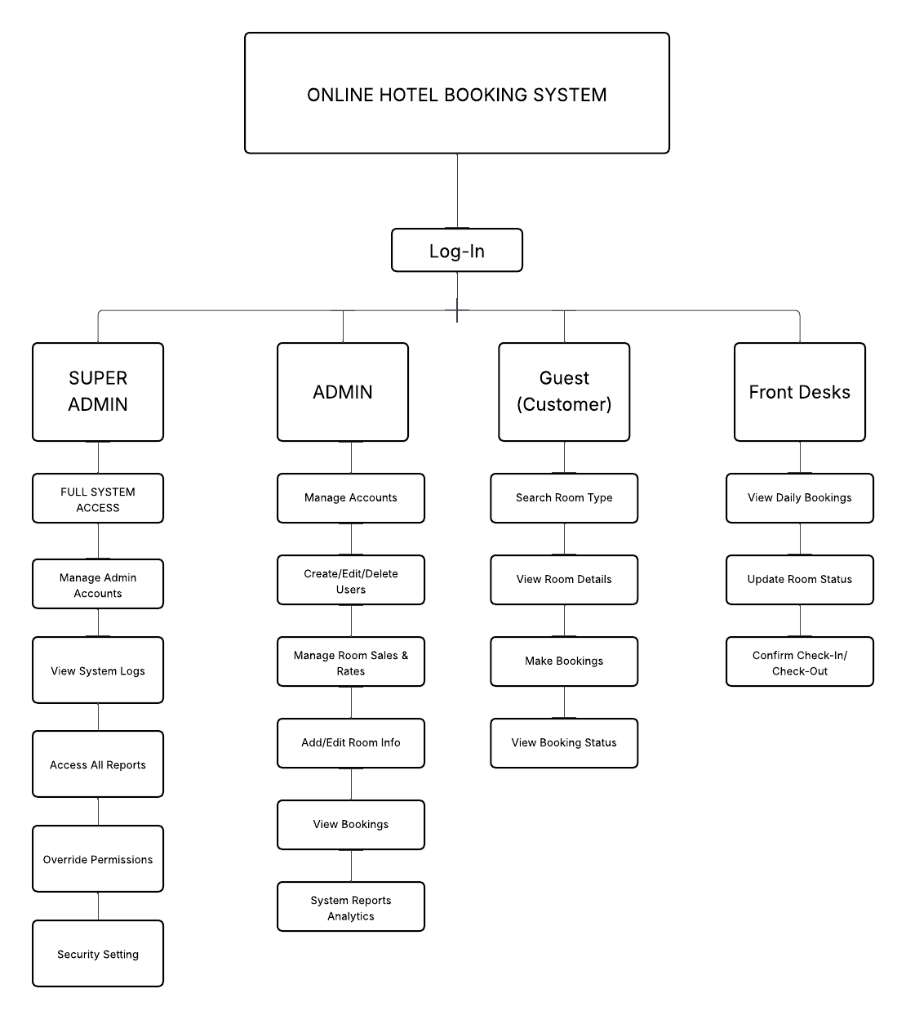

**Figure 2**

**Work Breakdown Structure**

**Cost and Benefits**

**Intro.**

**Table 1**

**Existing Cost**

|  |  |
| --- | --- |
| **EXISTING WEBSITE EXPENSES** | |
| Developers Salary (Front end and Back end) |  |
| Web Hosting |  |
| Print Expenses |  |
| Bond Papers for Printing Documents |  |
| **Total =** | |

**Table 2**

**Development Cost ( Total Expenses )**

|  |  |
| --- | --- |
| Position | Monthly Salary |
| Front End Developer | 25,000 |
| Back End Developer | 35,000 |
| Web Hosting | Unya ra |
| **Total =** | |

The table shows the Development Cost which is PHP .00. The expenses listed would be the amount needed from the client that they need to invest in the Online Hotel Booking System.

**Figure 3**

**Monthly Expenses**

The table below shows the existing cost and the expenses of the developer of the existing online hotel booking system.

**Table 3**

**Deployment Cost**

|  |  |
| --- | --- |
| **EXPENSES** | **COST** |
| **Developers Salary (Front end and**  **Back end)** |  |
| **Web Hosting** |  |
| **Print Expenses** |  |
| **Bond Papers for Printing Documents** |  |
| **Total =** | |

The development cost is the breakdown of the expenses during the deployment of the website.

To calculate, the annual profit by subtracting the total cost of developing the current website from the total cost of the deployment. The annual profit is calculated as follows:

Development Cost ( **PHP** ) - Deployment Cost ( **PHP**  ) = **PHP**

The ROI or the Return on Investment of the total investment would be divided by the half-year profit which is **PHP**

According to this Calculation, the client will receive their investment back within dapat years

**MOSCOW**

**IMPLEMENTATION OF ONLINE HOTEL BOOKING SYSTEM**

Must Have:

1. Hotel room listing and availability display
2. Online reservation and booking functionality
3. Admin dashboard to manage rooms, bookings, and users
4. Booking confirmation and unique reference number generation

Should Have:

* Admin Accounts
* Email/SMS notification for booking confirmation and reminders
* Customer profile and booking history
* Search and filter rooms by type, price, and date

Could Have:

* Customer feedback and review system
* Promo code or discount voucher feature
* Multilingual support for foreign customers

Won't Have:

* Chatbot customer support system
* Integration with third-party travel or flight services
* Mobile app version

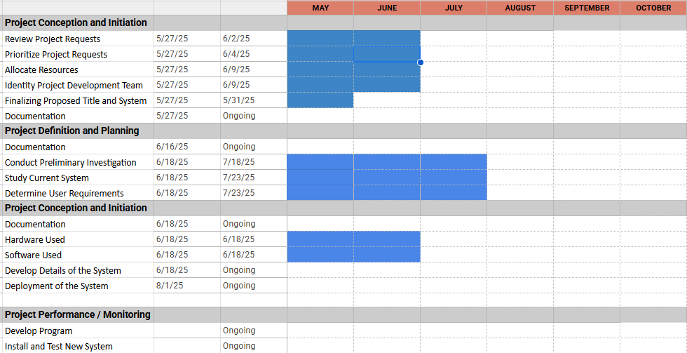

**Figure 4**

**The Ghantt Chart**

**Critical Path**

**Data and Process Modeling**

The transition to digital platforms in the hospitality industry has significantly transformed how reservations are managed, tracked, and processed. This capstone project focuses on the development of an online hotel booking system that utilizes data and process modeling to streamline booking procedures, reduce human error, and enhance overall efficiency and user experience. Through process modeling, the system’s components are structured to ensure clear, organized, and efficient flow of information between users and the system. As part of data and process modeling, Data Flow Diagrams (DFDs) will be developed to visually represent the flow of data between external entities, system processes, and data stores. The modeling process begins with a Context Diagram, which illustrates the system as a single process interacting with external users such as guests and administrators. This high-level view outlines the scope of the system, including inputs such as room availability requests and reservation details, and outputs such as confirmation messages or updated schedules.

**Existing Flowchart**

**Proposed Flowchart**

**Use Case Diagram**

**Narrative**

**Activity Diagram**

**State Chart Diagram**

**Design**

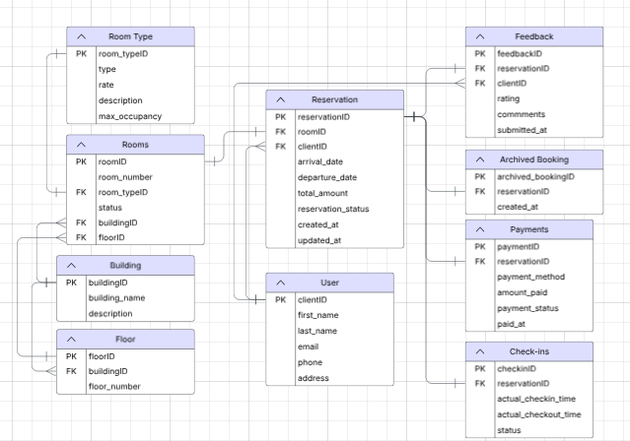

**Figure 25**

**Entity Relationship Diagram**

**System Architecture**

**Security**

Data security refers to the practice of protecting digital information throughout its entire lifecycle from unauthorized access, breaches, and data corruption. It involves a combination of technological safeguards and procedural controls to ensure the confidentiality, integrity, and availability of sensitive information. For an online hotel booking system, data security is crucial in safeguarding customer information, booking records, and administrative operations. The following measures are implemented in our system to maintain a secure environment:

**Authorization**: To ensure data confidentiality and privacy, the system implements role-based access control. Only authorized users—such as guests, hotel staff, and administrators—are granted access to specific functionalities and data according to their designated roles.

**Strong Passwords**: All system users are required to create strong, complex passwords to access their accounts. This security measure prevents unauthorized individuals from gaining access to sensitive data, including customer profiles and administrative settings.

**Two-Factor Authentication (2FA)**: To enhance login security, the system implements two-factor authentication. This requires users to verify their identity through a secondary method (such as a one-time code sent via SMS or email) in addition to their password. 2FA greatly reduces the risk of unauthorized access even if login credentials are compromised.

**Updates and Maintenance**: The system undergoes scheduled updates and routine maintenance to address software vulnerabilities, apply security patches, and enhance performance. This proactive approach ensures the platform remains reliable, secure, and compliant with current data protection standards.

**Data Privacy Policies**: The system complies with relevant data privacy laws and regulations to ensure that users’ personal data—such as names, contact details, and booking history—is collected, stored, and processed lawfully. Clear privacy policies are displayed on the platform to inform users about how their data is used, their rights regarding their information, and the measures taken to protect it.

**Development**

**Hardware Specification**

**Chapter 5**

**SUMMARY, CONCLUSION AND RECOMMENDATION**

**Summary**

**Conclusion**

**Recommendation**

**DEFINITION OF TERMS**

**BIBLIOGRAPHY**

**ONLINE SOURCES**

Bilgihan, A., Nusair, K., Okumus, F., & Cobanoglu, C. (2013). Online experiences and flow theory: A study on hotel booking websites. International Journal of Hospitality Management, 32, 1–10. https://doi.org/10.1016/j.ijhm.2012.04.004

Roberts, J. A., Berger, P. D., & Crotts, J. C. (2019). A theory of lodging: Understanding guest experience in public and private spaces. Journal of Hospitality and Tourism Insights, 2(3), 245–259. https://doi.org/10.1108/JHTI-02-2019-0034

Manachynska, A. V., Nalyvaiko, O. V., & Yermakova, T. O. (2020). Optimal hotel management: A modern management theory approach. Journal of Tourism and Hospitality Management, 8(1), 15–28. https://doi.org/10.15640/jthm.v8n1a2

**Related Literature**  
Faliha, F., Ahmad, N., & Rahman, R. (2021). Impact of Online Reservation Systems and Customer Reviews on Brand Trust and Booking Decisions. Journal of Tourism Technology, 12(3), 225–240.

Goecke, H. (2020). The Evolution of Online Booking Systems: From Airlines to E-Tourism Platforms. International Journal of Hospitality Management, 86, 102428. https://doi.org/10.1016/j.ijhm.2019.102428

Hussein, M., Selamat, M. H., & Haron, H. (2010). User Experience in Internet Booking: Challenges and Opportunities. Journal of Computer Science, 6(1), 57–65.

Kushwha, V., Sharma, D., & Gupta, S. (2024). Hotel Booking Website: A System for Operational Efficiency and Customer Satisfaction. International Journal of Software Engineering and Applications, 15(2), 112–120.

Park, Y., Gretzel, U., & Sirakaya-Turk, E. (2018). Understanding Online Hotel Booking Process: A Choice-Set Perspective. Journal of Travel Research, 57(2), 154–167. https://doi.org/10.1177/0047287516683832

**Related Studies**  
Ani, J. A. (2019). User Interface Design of Online Travel Booking Applications: An Evaluation and Proposal. Journal of Web Development and Design, 4(2), 45–60.

Baki, R. (2020). Factors Affecting Customer Trust in Online Hotel Booking Websites: An Empirical Study Using SEM. International Journal of Hospitality and Tourism Administration, 21(4), 356–372.

El Nemar, S., Kassem, M., & Al-Khatib, H. (2022). E-Service and Online Hotel Booking Intentions: An Application of the Extended TAM Model. Middle East Journal of Management, 9(1), 23–39.

El-Said, O. (2020). Impact of Online Reviews on Hotel Booking Intention: The Role of Brand Image, Price, and Ratings. Journal of Hospitality Marketing & Management, 29(7), 841–861.

Schwartz, Z. (2008). Time, Price, and Advanced Booking of Hotel Rooms: Revenue Management Challenges. Cornell Hospitality Quarterly, 49(1), 85–96. https://doi.org/10.1177/1938965507311501

**APPENDICES**

**APPENDIX A**

**RELEVANT SOURCE CODE**

**APPENDIX B**

**APPENDIX C**

**GRAMMARIAN’S CERTIFICATE**

**CURRICULUM VITAE**

**MARK ANTHONY AÑASCO**

**Pusok Lapu-lapu City, Cebu Philippines 6015**

**0960-865-3930**

[**markanasco55@gmail.com**](mailto:markanasco55@gmail.com)

**Hi! I'm Mark Añasco, a passionate Frontend Developer from Cebu, Philippines, with expertise as a Web Designer, Developer, and WordPress Developer. I specialize in building visually appealing and user-friendly interfaces using my technology stack. My strengths include attention to detail and ability to deliver seamless user experiences. I stay up-to-date with the latest trends and use tools such as Figma. Additionally, I excel in utilizing development platforms such as WordPress to create engaging.**

**EDUCATION**

**Senior High School   Benedicto College**

**Diploma   Bachelor Of Science in Information Technology**

**Advance Institute Of Technology   (2021-Current)**

**(2020 - 2021)**

**TECHNICAL SKILLS**

* **HTML5**
* **CSS3**
* **Javascript**
* **Bootstrap**
* **WordPress**
* **Figma**
* **Windows**

**WORK SKILLS**

* **Knowledge bootstrap and media queries for mobile responsive**
* **knowledge into design and creation of user interfaces**
* **Up-to-date with the latest web design techniques and trends**
* **Knowledge in WordPress development**
* **Knowledge about APIs, with an understanding of HTTP methods like GET, POST, PUT, and DELETE.**
* **Maintenance**
* **Operation Management**
* **Customer Service**

**CERTIFICATIONS                                                                      AWARDS**

**Supreme Student Council | BENEDICTO COLLEGE**

**2022-(MAIN CAMPUS)**

**PSITE Central Visayas | ICT STUDENT CONGRESS - CEBU**

**2023 - (CTU MAIN CAMPUS)**

**Supreme Student Council | BENEDICTO COLLEGE**

**2024-(MAIN CAMPUS)**

**PSITE Central Visayas | ICT STUDENT CONGRESS - CEBU**

**2024 - (CTU MAIN CAMPUS)**